**PROJECT POPLIN**

**MEDICAID REFERENCE ARCHITECTURE**

**CARE/CASE SERVICE DEFINITIONS**

**MITA Governance Board**

**Poplin Working Group**

# POPLIN Project Background

The Centers for Medicare and Medicaid Services (CMS) seeks to develop a robust module marketplace for Medicaid to promote competition of solutions, reduce risk, streamline certification, and better serve the needs of individual states’ Medicaid Enterprise Systems (MES) through standards and conditions for its funding of state implementations. Such conditions include application of modular design, development, and deployment methodologies and technologies for state-specific MES components and reuse of those components when possible.

To help states and vendors prepare for and use a module marketplace for Medicaid, CMS has sponsored efforts with MITRE Corporation through its Federally Funded Research and Development Center’s (FFRDC) CMS Alliance to Modernize Healthcare (CAMH) to develop a reference architecture (Project Poplin) than can extend the Medicaid Information Technology Architecture (MITA) technical architecture.

Poplin seeks to provide standard definitions for application services that enable MES implementations across a diversity of state requirements so that vendors can develop robust technologies with broad application. This Service Definition Template defines the components required in a service definition document.

# Modular Example

In Figure 1 - Modular Overview below, we see an example of a small cross section of the Medicaid enterprise. These systems have dependencies on each other that require them to closely communicate with each other.

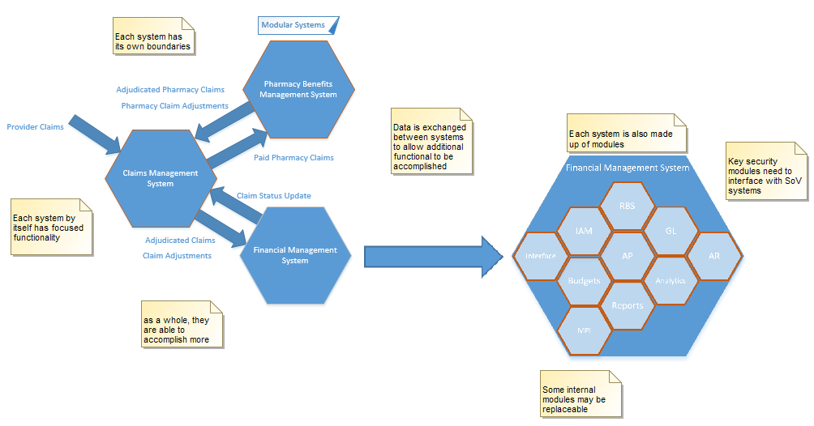

Figure - Modular Overview

As shown above in the Financial Management System example, not only is there communication at a high level between systems but there are also internal modules. Each system of the Medicaid enterprise can be broken down this way. The goal of this effort is to:

1. Identify each module
2. Determine if it can reasonably be separated and reused
3. Define the “Glue” needed to connect these components together

In Figure 2 - Modular Breakdown Sample, we have taken a Case Management Module and broken it down into its component parts.

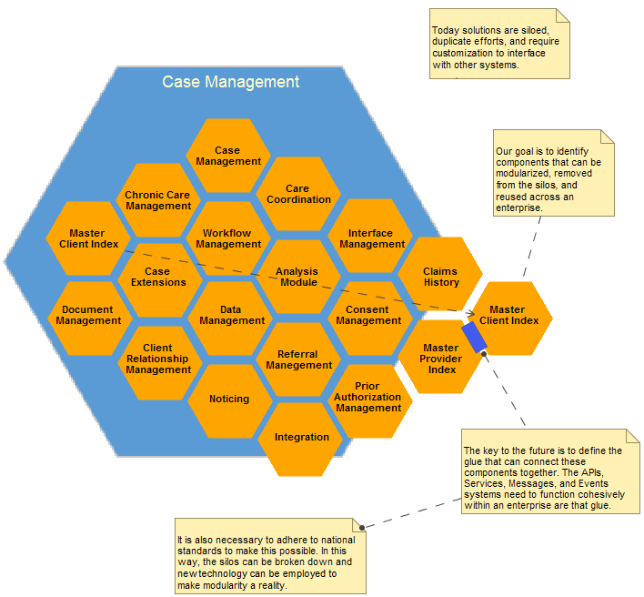

Figure - Modular Breakdown Sample

# Introduction

This document breaks down the MITA Care Management Business Processes and systems to their component level and defines a reference standard for how these components can communicate in a modern Medicaid Enterprise.

# MITA Business Processes

Although the focus of this document is to look at Case Management processes, which falls under the Care Management Business Area, we find important dependencies to most other business areas. These dependencies highlight the areas where standard services, or API’s, must be established for modularity to be possible. The two figures below show the MITA processes by Business Area.

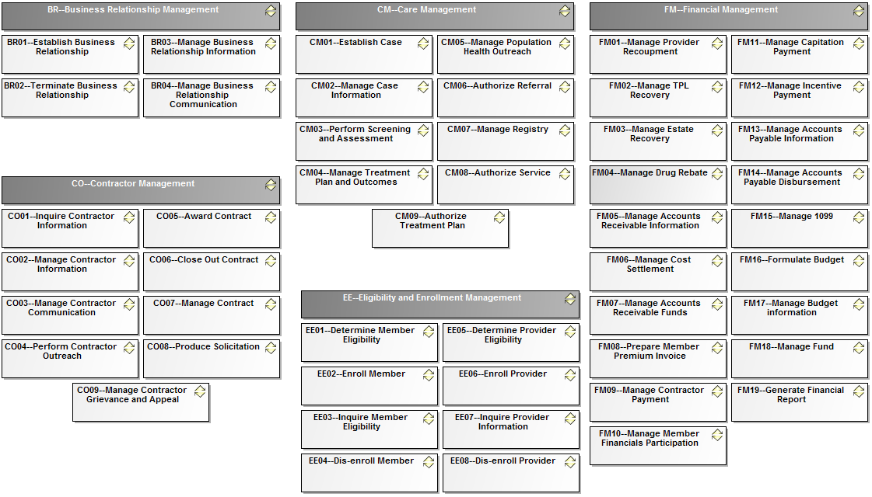

Figure - MITA Business Processes A

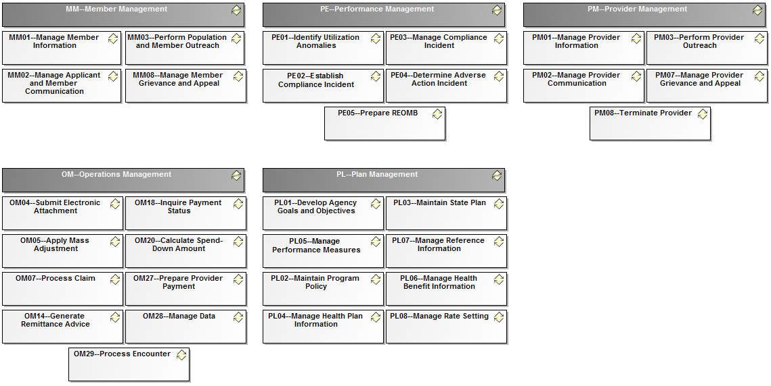

Figure - MITA Business Processes B

The next two figures show the MITA Care Management Business Area processes and their dependencies to other MITA Business Area processes:

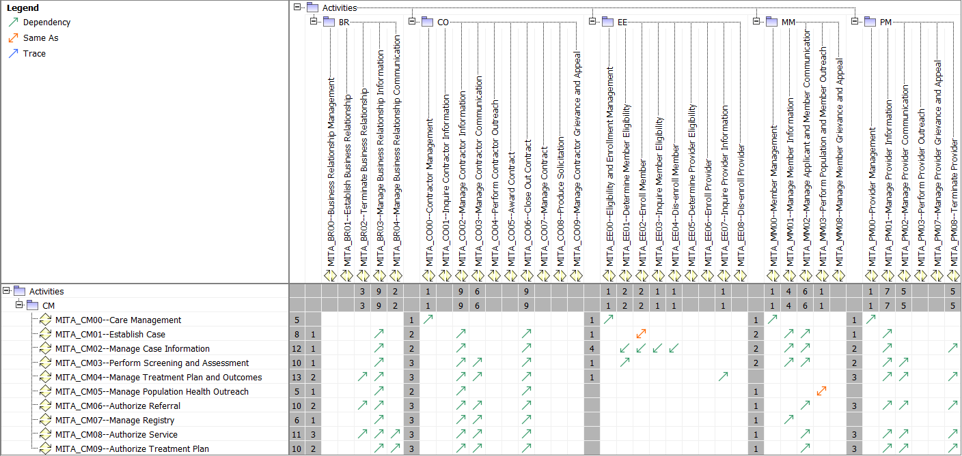

Figure - MITA CM Dependencies A

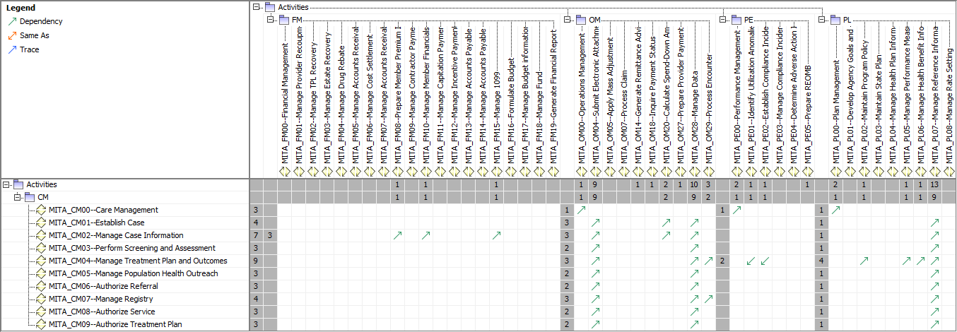

Figure - MITA CM Dependencies B

# Communications

Before we begin identifying minimum functionality of services for MES implementations we want to identify what means should exist to allow systems to interact.

There are basically three ways systems can communicate with each other

1. Batch Interface  
   Best suited to exchange reference data that does not change frequently. One example would be a list of ICD-10 codes. This method is not preferred.
2. Real-Time Interface  
   This type of interface is necessary when requesting time sensitive information or the most accurate data in an ever-changing environment. One example of this would be a request to see if a client is currently enrolled, or eligible, to receive a service.
3. Event Driven Interface  
   This is a key component of any enterprise. When data is changing in multiple systems there is a need for notifying others of changes that could affect their activities. One example would be if a provider was no longer eligible to perform services we would want the Case system to be aware of this as soon as possible. In this type of environment, a message would be generated, and the Case solution would see the message and process it as needed.

Solutions can expose functionality in multiple ways to handle these types of communications. Publishing API’s, SOA Services, and a Messaging Service are a few of the desirable ways. These methods are really a layer of abstraction away from the underlying complexity that allows multiple systems to communicate in a standard way. This also enables the realization of a more modular enterprise.

# High Level Case Management Business Processes

As we focus more specifically on case management we find many standards that identify Case Processes. A generally accepted list of high level case functionality includes:

|  |
| --- |
| **Op-Pr High Level Case and Care Activities Table** |

| **Name** | **Documentation** |
| --- | --- |
| Case - Initiate | This covers the processing of incoming referrals and other information that are the basis for case creation. |
| Case - Engage | Successful engagement is the basis of effective case management. Engagement establishes the relationship and sets the ground rules which are enhanced and reviewed throughout the phases of case management. Engagement begins prior to the initial contact between the case manager and the person requiring services, their family and/or career. |
| Case - Assess | Assessment is a dynamic and ongoing process where information is gathered from a range of sources about a person, including their life situation, and formal and informal supports. The range of information is then considered in the context of information and advice from the person with a disability, their family and/or careers and informal supports. Information may be obtained from a range of sources, including written reports or records, verbal reports and observations and impressions of the case manager. |
| Case - Plan | The goals, needs and wishes of the client form the basis of a plan. A plan is a map of actions that documents the issues, methods, responsibilities and timeframes needed to meet the identified goals. |
| Case - Implement | Implementation is the process of putting into action the plan developed by the case manager, together with the person, their family and other supporting team members. The aim of implementation is to help the person achieve their goals and desired outcomes, identified in the assessment and planning phases. |
| Case - Monitor | Monitoring is an active and ongoing process where aspects of the planning and implementation phases are reviewed. It identifies the effectiveness and relevance of planned goals, focusing on the timeliness and success of strategies being used to achieve these goals. Additionally, it provides the opportunity to adjust the plan to address any unanticipated problems. |
| Case - Review | Case management practice involves regular formal and informal review processes. The review phase is important to help ensure that outcomes for people are relevant to their needs and include a focus on community inclusion and participation. The review process should be driven by, and inclusive of, the client and how they feel the process is working. |
| Case - Transition | Transition can occur for many reasons and involves creating a plan with the clients and other supports to insure they receive the care needed. This could happen when a client has reached the goals applicable to the services being rendered or is no longer eligible. In these cases, clients are generally referred to other resources for continued assistance. |
| Case - Close | Cessation of involvement by a case manager or the closure of a case may be influenced by many factors. These factors may relate to organizational or agency requirements in which a limited time frame is identified for the case manager involvement with any one client. This may raise significant concerns or questions as to the appropriateness of terminating contact. The decision as to whether to cease involvement or close the relationship can be influenced by a number of factors. |
| Case - Analyze | Analyze data to determine where evidence shows changes are needed to improve outcomes, to detect fraud, and to verify utilization of services. |
| Case - Supports | There are many supporting functions necessary for enabling the care and case functionality. Managing reference data, security, auditing, and historical data are just a few areas of concern. |

Tracing each process in any system that is part of the Medicaid enterprise is essential in identifying the areas where standards are needed. Without this analysis and the development of the standards around information and processes to be exposed the desired level of modularity will be difficult to obtain.

The next two figures we have traced the high-level case processes to the applicable MITA Business Processes. The results are shown in the following two figures:

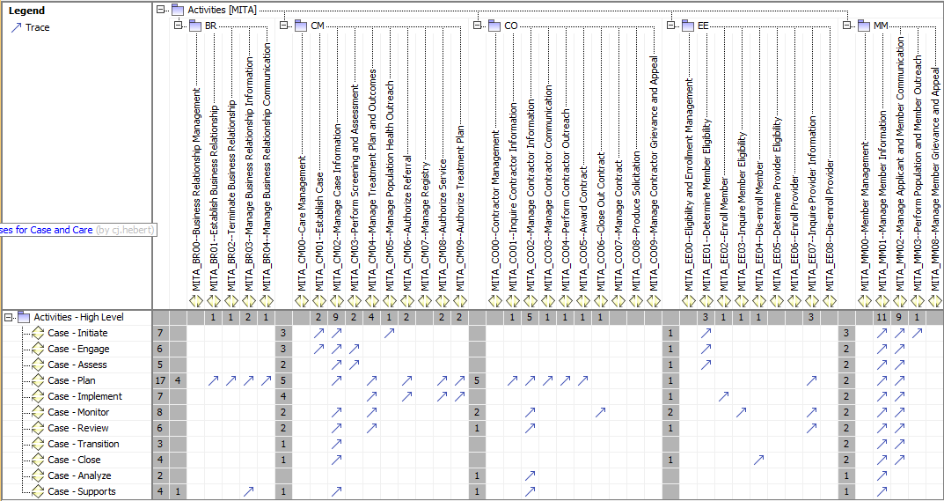

Figure - Case to MITA Business Processes A

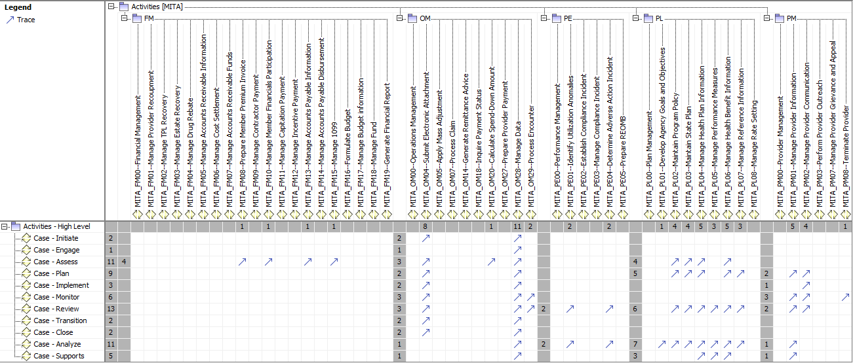

Figure - Case to MITA Business Processes B

# System Dependencies

When you look at Care and Case Management processes you find that there are many dependencies required within the Medicaid enterprise. We will break down these individual dependencies where they apply and outline the necessary services required to allow these components to communicate.

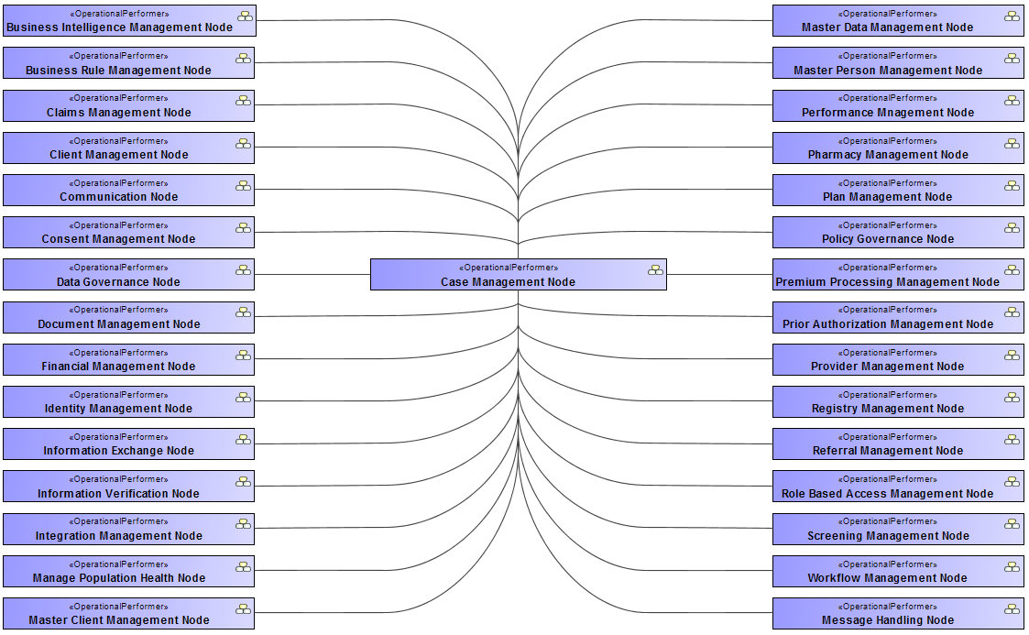

Figure – High Level Care and Case Dependencies

From the image above its easy to see how interconnected the systems that make up Human Services can be. It is essential that the proper sub-systems are in place to make the migration to a common modular future state possible, progress in a logical fashion, and reusable.

## Foundational Dependencies

The image below shows a sample of how systems and their dependencies build on each other.

At the root of any effort is the necessity of policy and governance to set the stage for all future efforts. Management of data begins with, and is the realization of, policy and governance.

Moving up, the next layer contains base infrastructure requirements and common components required to enable and support the enterprise. The components at this level implement the common functions such as rules, workflows, and security.

The next layer enables the business of providing services. This includes all the tool for analysis, management of business information (such as plans), and financial processing.

The uppermost layer contains the modules that allow us to directly engage with those who have a need. Here we manage and implement the processes necessary to support individuals.

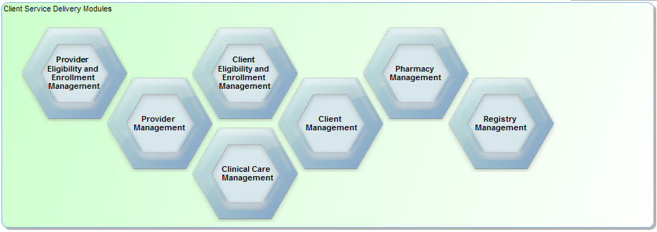  
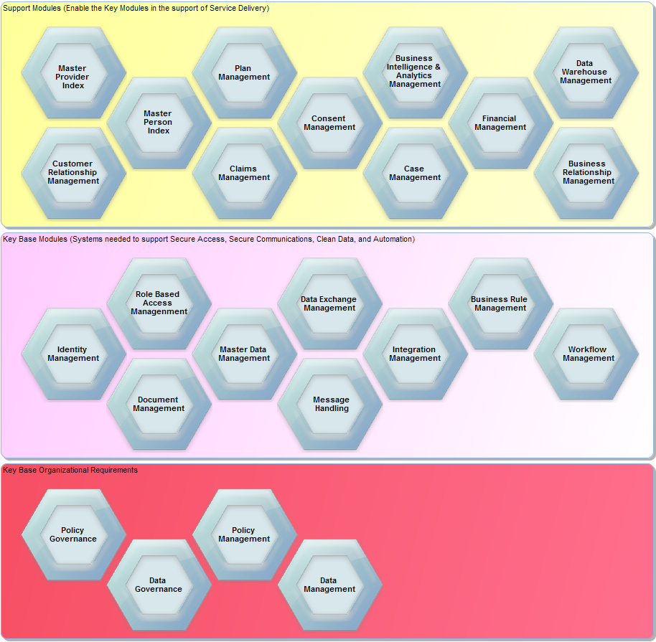

Figure - Enterprise Module Foundation